NAND GATE
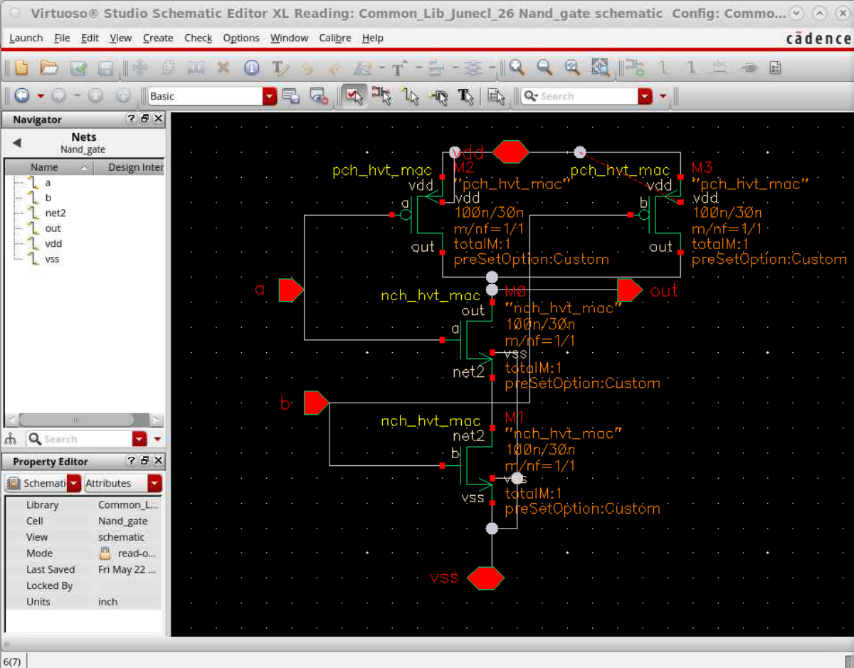
This is the schematic that was given to me of the NAND gate that had to be created, that will be used with the inverter to create the AND, which will ultimately be used to create the XNOR. This is all in the 28 nm TSMC technology. The layout I made:
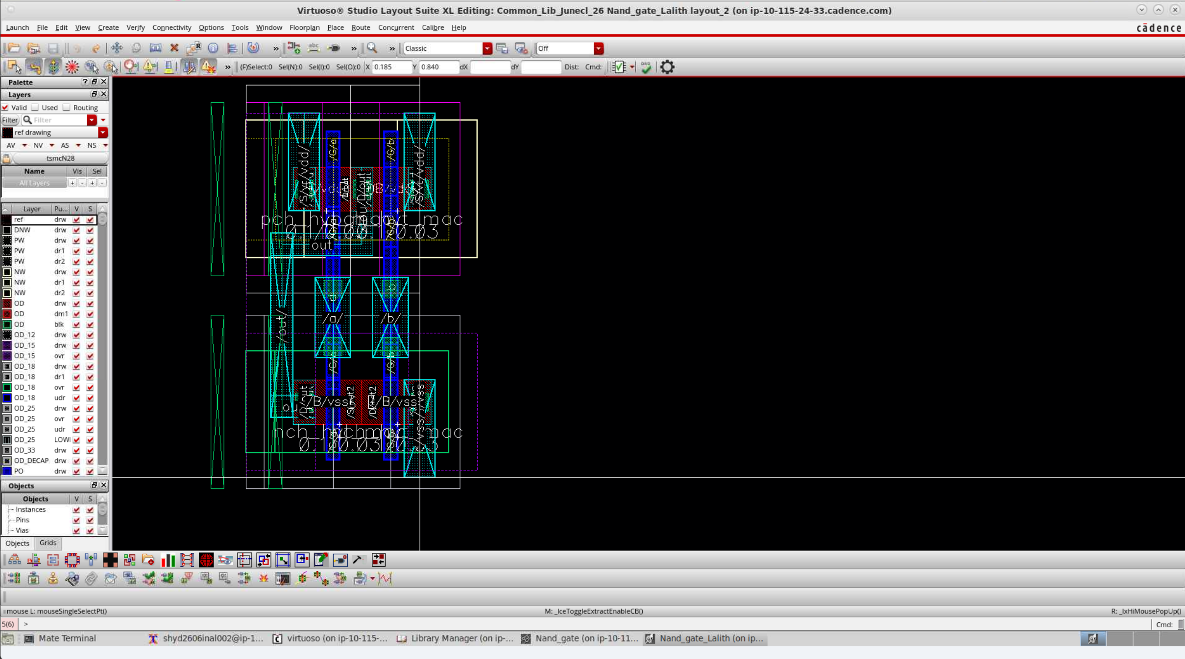
The layout Created was as optimised as possible and was having the necessary half drc measures and is LVS verified. It had all the connections made within only the necessary spacing to optimise the area and the size enough to combine and connect with all the inputs and outputs of each inverter and this nand gate to make the and gate. This had same performance but least and optimal size possible.
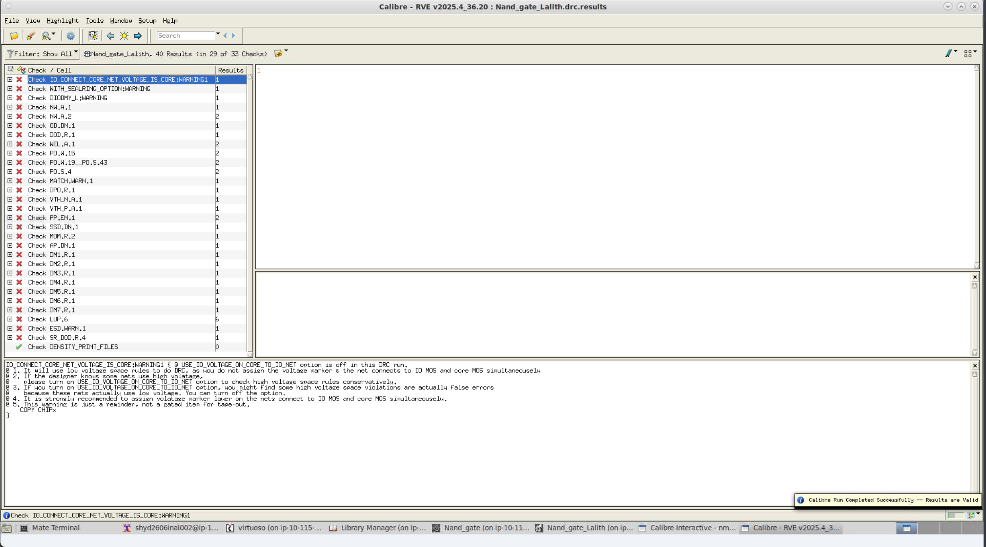
The DRC shows the same errors as Inverter that can be cleared on the top level and some other errors that can be ignored like the dummy spacing, density errors etc. This NAND gate is also upon placing of bulks, LVS and DRC verified.

